9/20/2020
Lixiao Yue
[company name]
Predicting Car Accident Severity for Seattle City
Capstone Project

Contents
1. Introductory 2
1.1. Background 2
1.2. Problem and Requirement 2
2. Methodology 3
2.1. Data sources 3
2.1.1. Data Cleaning 3
2.1.1.1. Initial feature selection 3
2.1.1.2. Missing data 4
2.1.2. Data Formating 5
2.1.3. Feature check 5
2.1.4. Pre-processing 7
2.1.4.1. Imbalance Data 7
2.1.4.2. One Hot Encoding 8
2.1.4.3. Dimensionality Reduction (Optional) 8
2.1.4.4. Normalization/Standardization 8
2.2. Predictive Model 9
2.2.1. Predictive Model 10
2.2.2. Parameter Optimization 11
2.2.2.1. Decision Tree 11
2.2.2.2. Logistic Regression 12
3. Results 13
4. Conclusion/Discussion 15
5. References 15
6. Acknowledgment 15

Introductory

Background
Motor vehicle travel is the main means of transportation in the world. It provides great convenience and opportunity for personal control and autonomy. However, there are problems need to be addressed for improved safety.
This project will build a predicting system to identify the factors which are affecting traffic crash severity, predict the crash severity class based on selected factors such as weather condition, road condition, Speed and traffic control condition.
Based on the result or the understanding, Transport department would have an idea or direction to prevent and reduce traffic accident, such as improving road condition, adding traffic light/signs; People would pay attention at known Accident prone area and carefully deal with various road/traffic situations. Also, for car vendors, that information would be a good guidance for improve car safety equipment/sensor.

Problem and Requirement
How to predict the crash severity? The requirement will be followings:
- Understand explicitly what factors led to the road accident
- Predict Car Crash Severity class for each accident
Based on the dataset (Data-Collisions.csv) provided in capstone project, there are only two crash severity - 1. Property Damage Only Collision and 2. Injury Collision, but as checked other data source (e.g. Australia and New Zealand's data, the Severity are usually divided to four classes), I consider it is a multiple classification problem.

Methodology

Data sources
Before starting, I checked different data sources - open data of VIC Australia, NYC USA. They are not good enough and had lots of missing data. I decided to use the dataset (Data-Collisions.csv) provided in the capstone project.

Data Cleaning

Initial feature selection
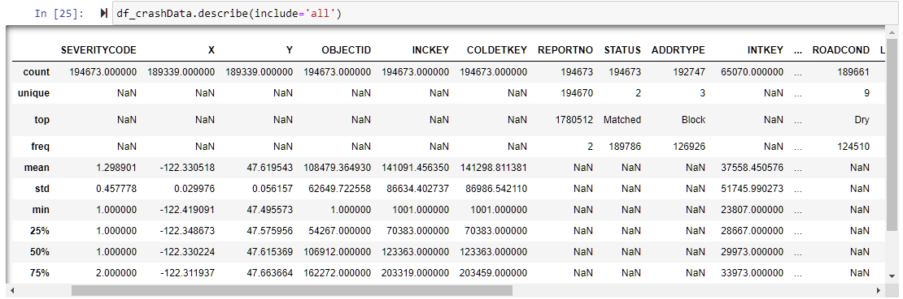
Figure 1 Data Describtion
As reviewed metadata, removed all non-relevant columns.
Table 1 Selected Features
Selected feature | Description | Remark
SEVERITYCODE | A code that corresponds to the severity of the collision  • 2—injury • 1—prop damage
COLLISIONTYPE | Collision type
PERSONCOUNT | The total number of people involved in the collision
PEDCOUNT | The number of pedestrians involved in the collision. This is entered by the state.
PEDCYLCOUNT | The number of bicycles involved in the collision. This is entered by the state.
VEHCOUNT | The number of vehicles involved in the collision. This is entered by the state.
INCDATE | The date of the incident.
INCDTTM | The date and time of the incident.
JUNCTIONTYPE | Category of junction at which collision took place
SDOT_COLCODE | SDOT_COLCODE
INATTENTIONIND | Whether or not collision was due to inattention. (Y/N)
UNDERINFL | Whether or not a driver involved was under the influence of drugs or alcohol.
WEATHER | A description of the weather conditions during the time of the collision.
ROADCOND | The condition of the road during the collision.
LIGHTCOND | The light conditions during the collision.
PEDROWNOTGRNT | Whether or not the pedestrian right of way was not granted. (Y/N)
SPEEDING | Whether or not speeding was a factor in the collision. (Y/N)
ST_COLCODE | A code provided by the state that describes the collision. For more information about these codes
HITPARKEDCAR | Whether or not the collision involved hitting a parked car. (Y/N)

Table 2 Removed Columns
Removed Column | Description | Remark
SEVERITYCODE.1 | N/A
X | Longitude
Y | Latitude
OBJECTID | ESRI unique identifier
INCKEY | A unique key for the incident
COLDETKEY | Secondary key for the incident
REPORTNO | N/A
STATUS | N/A
LOCATION | Description of the general location of the collision
EXCEPTRSNCODE | N/A
EXCEPTRSNDESC | N/A
SEVERITYDESC | A detailed description of the severity of the collision
SDOT_COLDESC | A description of the collision corresponding to the collision code.
SDOTCOLNUM | A number given to the collision by SDOT.
ST_COLDESC | A description that corresponds to the state’s coding designation.
SEGLANEKEY | A key for the lane segment in which the collision occurred.
CROSSWALKKEY | A key for the crosswalk at which the collision occurred.

Missing data

2.52% Collision Type have missing value, it was changed to “Unknow” as a new category.
3.25% Junction Type have missing value, it was changed to “Unknow”.
15.31 Inattention Indicator are “Y”, all rest miss data which means “N”. It was filled by “N”.
2.51% UNDERINFL have missing value, it was changed to “Unknow” as a new category.
Some WEATHER and ROADCOND have missing value, it was changed to “Unknow” as it has similar portion (Severity) to existing “Unknown” category.
2.66% LIGHTCOND have no value, it was changed to “Unknow” as it has similar portion (Severity) to the existing “Unknown” category.
2.4% PEDROWNOTGRNT are “Y”, all rest miss data which means “N”. It was filled by “N”.
4.97% SPEEDING are “Y”, all rest miss data which means “N”. It was filled by “N”.
Some categories of ST_COLCODE only have few samples (less than5), it was removed.

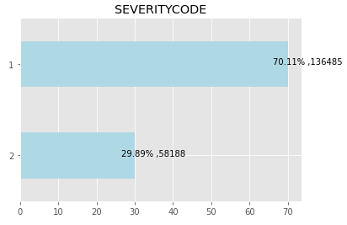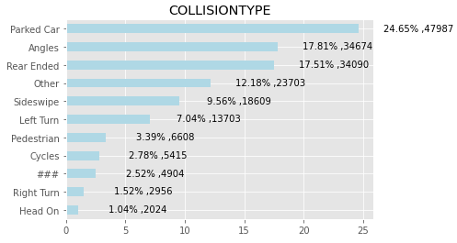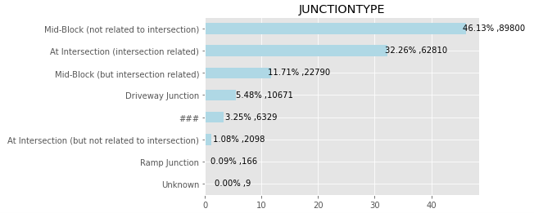
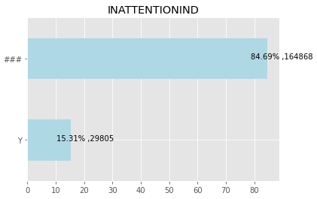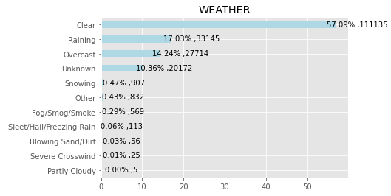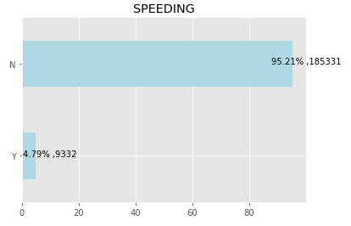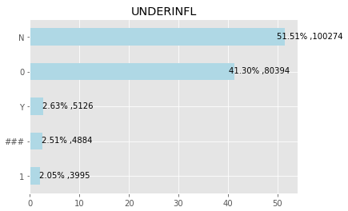
Figure 2 Data Cleaning

Data Formatting
Updated Object type to category type for DataFrame as below.
Before After
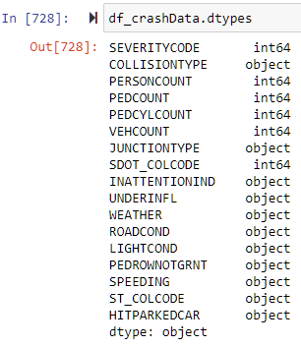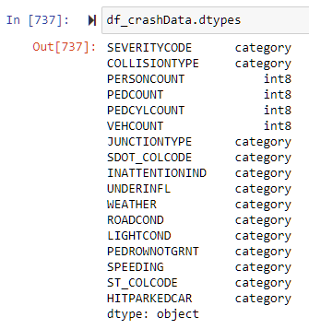
Figure 3 Data Type Correction

Feature checking
- Most accident involved two Vehicles and Severity of 75% accident are 2-Injury.
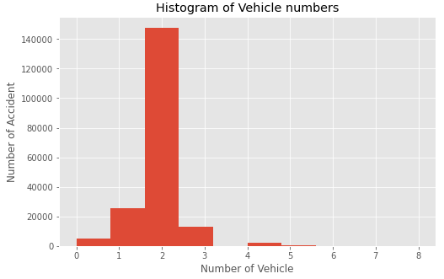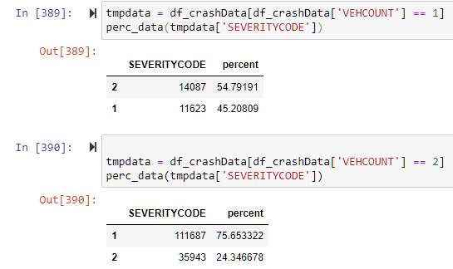

- Most accident didn’t involve pedestrian, but 90% accident are Severity 2 – injury when have 1 person involved.
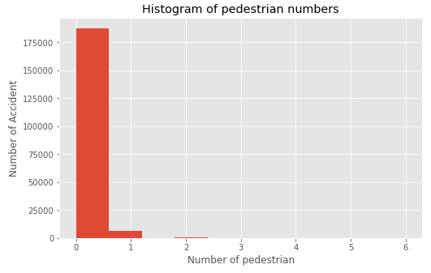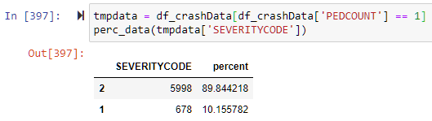

- Weather condition - Raining, Snowing didn’t cause more Severity 2 – injury. It seems people drive more carefully in bad weather condition.
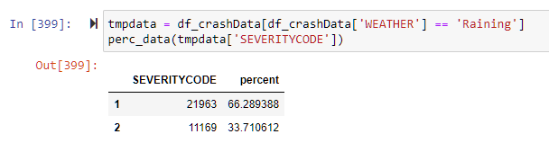
- Also 62% accident involved speeding caused Severity 1 – prop damage.
- Dropped more non-relevant columns.
Table 3 Removed features 2
Removed Column | Description | Remark
INCDATE | Date
INCDTTM | Time
ADDRTYPE | Collision address type | Duplicated with others
INTKEY | Key that corresponds to the intersection associated with a collision | Duplicated with others

Pre-processing

Imbalance Data
As pre-check, we found the sample data is unbalanced, it will be impact on the accuracy of prediction. Either Up-sampling or Down-sampling need to be applied. To have the best result, we do both Up-sampling and Down-sampling with the models then compare the results.
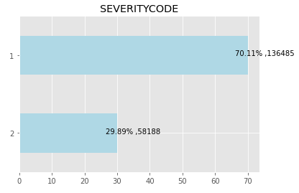
Figure 4 Imbalace Data
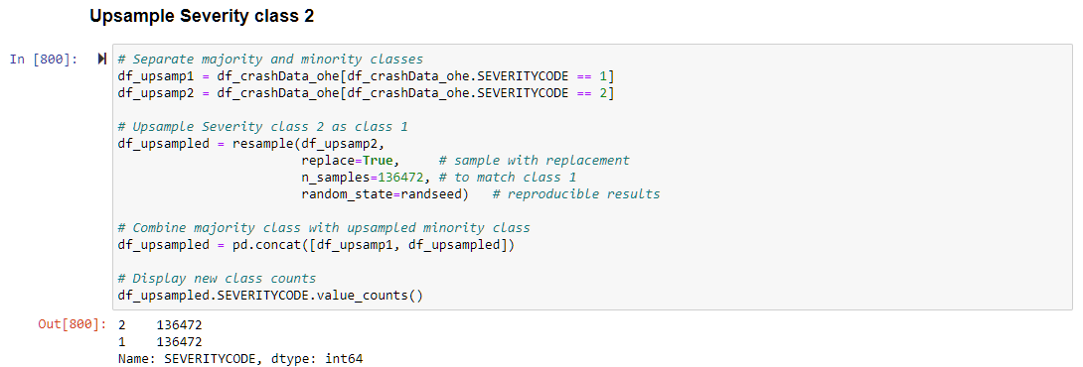
Figure 5 Un-sampling for class 2
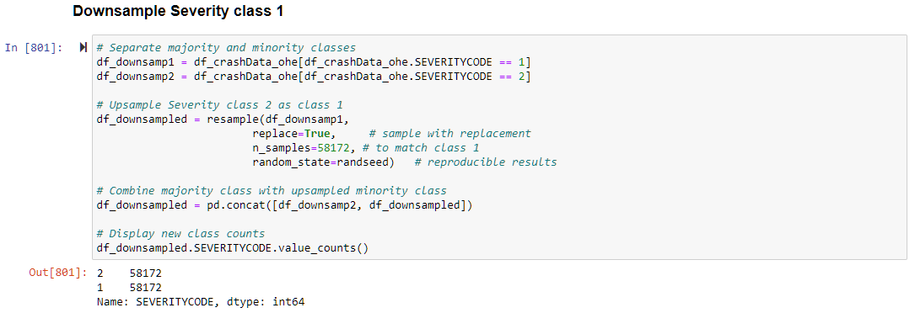
Figure 6 Down-sampling for class 1

One Hot Encoding
As there are some category in dataset, it cannot be fit to Models directly. The collection of categorical features is encoded using a 1-of-K encoding scheme, and added into columns.

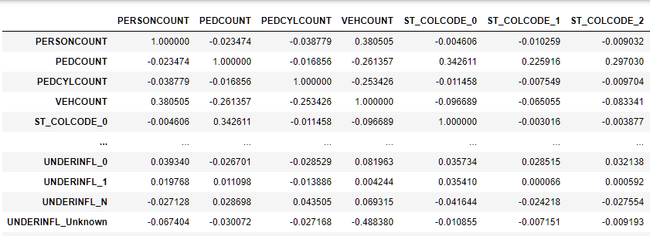
Figure 7 One-hot encoded Data

Dimensionality Reduction (Optional)
Now we had lots of new features after one-hot-encoding. It will take long time to fit&predict with models. Also, might cause overfitting problem. As an option, Features selection can be performed as Dimensionality Reduction with Class GenericUnivariateSelect().
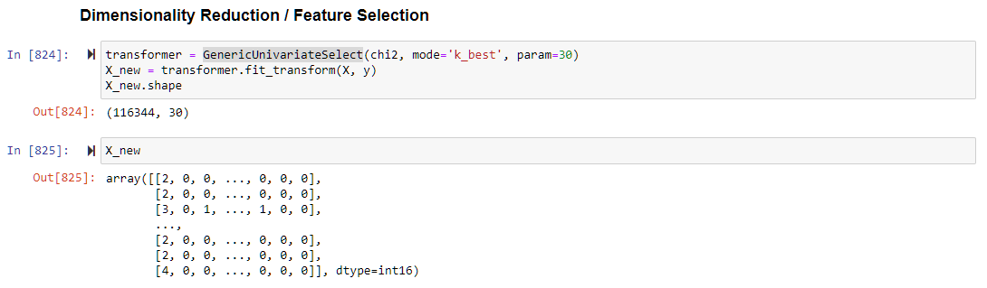
Figure 8 Dimensionality Reduction

Normalization/Standardization
Last step of Data pre-processing is Normalization. Its distribution will have a mean value 0 and standard deviation of 1. For Model of Decision Tree, no normalization is required.
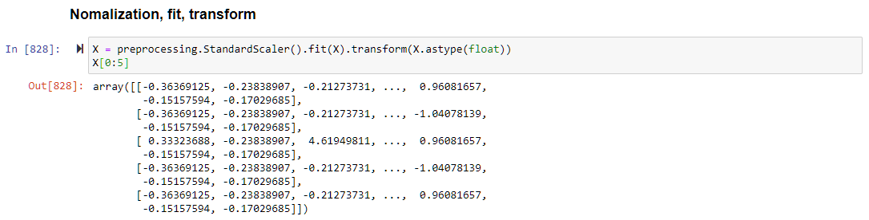
Figure 9 Normalization

Predictive Model

Predicting severity class is a classification problem. Many classification models can be used to predicting crash severity, K-Nearest Neighbours model can find the based on data similarity to other cases with the same severity labels near each other; Decision Tree model can choose the attribute of features from data, calculate the significance and split data based on the value of best attribute; Logistic Regression model is mainly for predicting the probability of cases, in this case it is also suitable for only two categories predicting; Support Vector Machine will map data to a high-dimensional feature space then find a best separator, basically SVM can be used as well, but it is not efficiency for large dataset.
I take all four models with supervised algorithm to initiate the analysis.

Predictive Model

When make prediction using test set, we got F1-Score and Accuracy which is close to the result using training set.
Using confusion matrix, the performance of K-Nearest Neighbours, Decision Tree, Logistic Regression and Support Vector Machine are comparable as below.
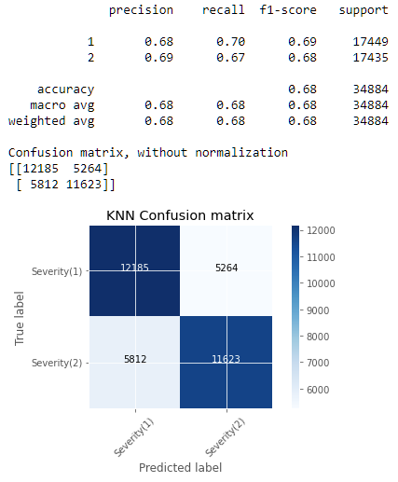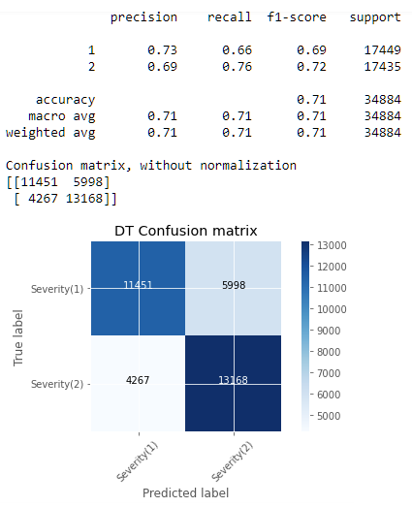
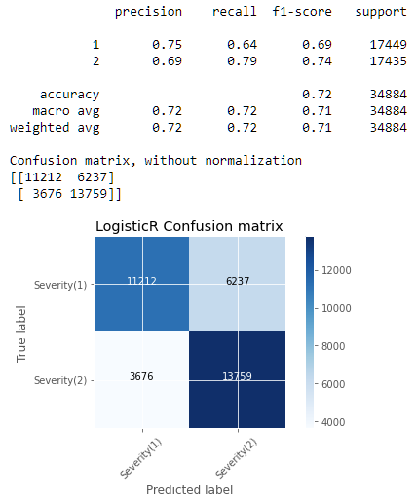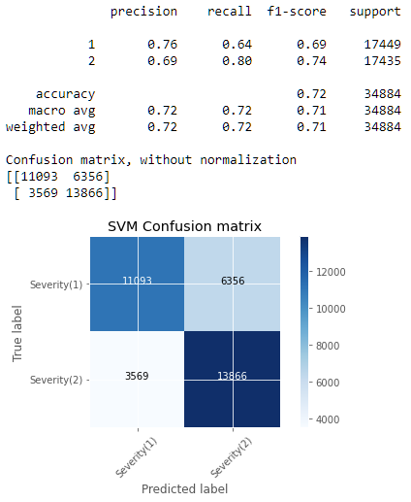
Figure 10 Confusion Matrix
Highest Accuracy ((TP+TN)/(TP+TN+FP+FN)): Decision Tree, Logistic Regression, SVM
Highest Recall (TP/(TP+FN)): Decision Tree, Logistic Regression, SVM
Highest Precision (TP/(TP+FP)): Decision Tree, Logistic Regression, SVM
According to comparison result using confusion matrix, Decision Tree, Logistic Regression and SVM model have same level accuracy. But SVM took quite long time for predicting. I selected Decision Tree, Logistic Regression model to solve the problem.

Parameter Optimization

Decision Tree
The main parameters have the key values need to be selected for this model as below. 'criterion':('gini','entropy'),
'splitter':('best','random'),
'max_depth':[10,20,30,50,70,80,90,100,100,120],
'max_features':('auto','sqrt','log2')
Using Grid Search Cross Validation, we got the validated result. It shows the best average test score is 0.70613949 with the 6th set of parameters.
The best parameters below are selected.
{'criterion': 'gini', 'max_depth': 20, 'max_features': 'auto', 'splitter': 'best'}
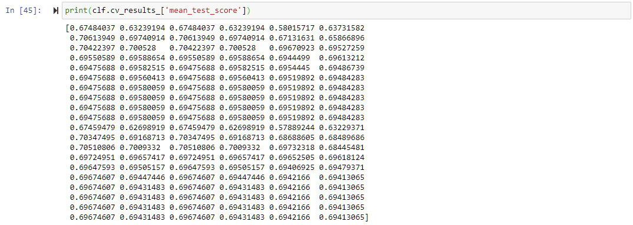
Figure 11 Mean_test_score
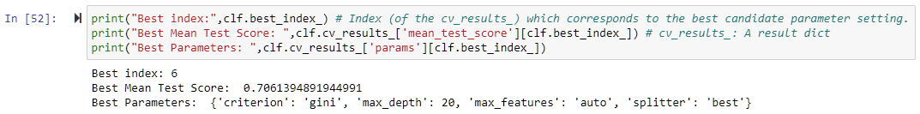
Figure 12 Best Parameter

Logistic Regression
The main parameters with the key values need to be selected as below.
'C':[0.001,0.1,1,5,10,100],
'penalty':('l1','l2','elasticnet'),
'solver':('newton-cg', 'lbfgs','liblinear','sag','saga')

Using Grid Search Cross Validation, we got the validated result. It shows the best average test score is 0.7171414538310412 with the 37th set of parameters. The nan values in table of mean_test_score are not an issue, it means the parameters are not supported by particular algorithm.
The best parameters below are selected.
{'C': 1, 'penalty': 'l2', 'solver': 'lbfgs'}
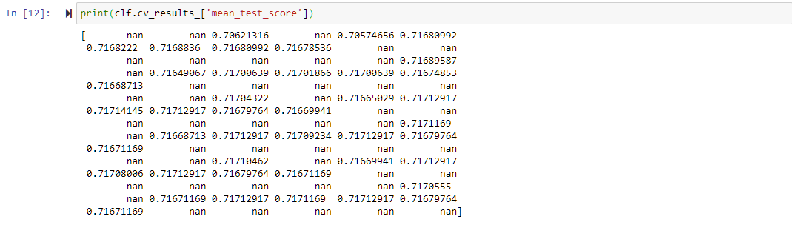
Figure 13 Mean_test_score
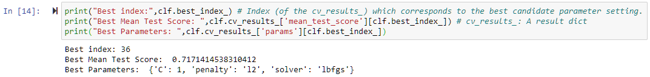
Figure 14 Best Parameter

Results
The result of Decision Tree Model with optimized parameter shows, F1-score is improved by 2%(0.72->0.74) and Recall is improved by 5%(0.76->0.81) for Severity 2-injury. Also F1-socre for Severity 1-POD had 1%(0.69->0.70) improvement when using up-sampling data.
The ROC curve using up-sampling data have better AUC(0.78->0.80).
Down-sampling Data Up-sampling Data
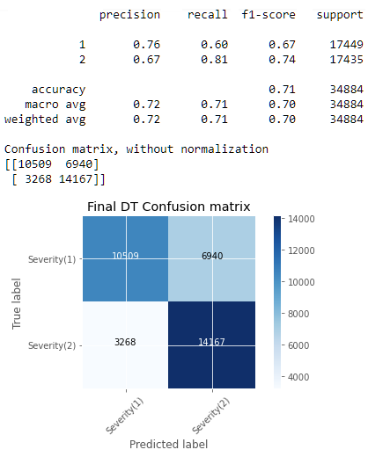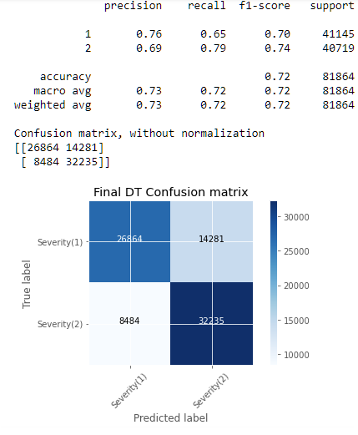
Figure 15 Final Confusion Matrix of Decision Tree
Down-sampling Data Up-sampling Data
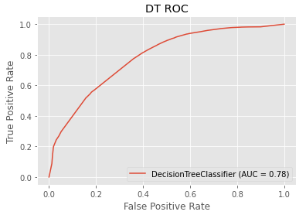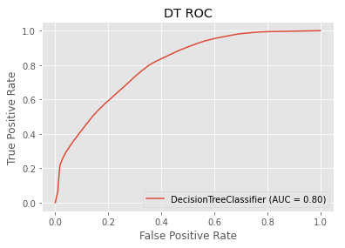
Figure 16 ROC Curves of Decision Tree

Regarding Logistic Regression Model with optimized parameter, all measurement remains same. Only when using up-sampling data. F1-score is improved by 2%(0.69->0.70) and Precision is improved by 1%(0.75->0.76) for Severity 1-POD.
Down-sampling Data Up-sampling Data
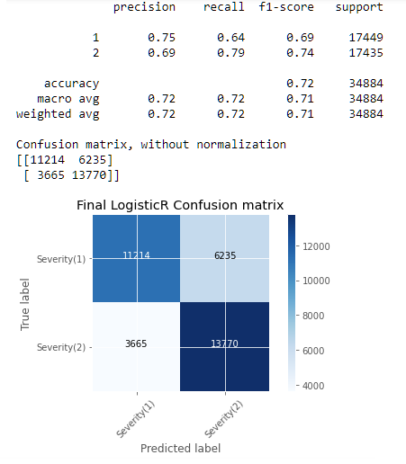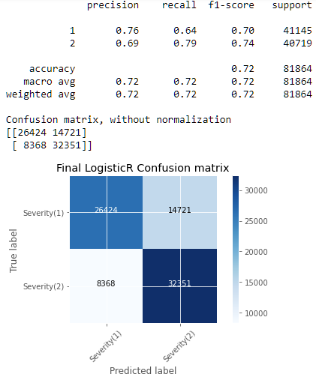
Figure 17 Final Confusion Matrix of Logistic Regression
Down-sampling Data Up-sampling Data
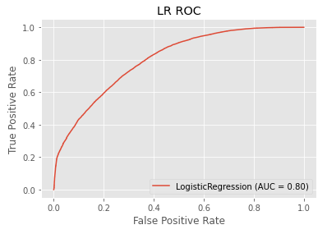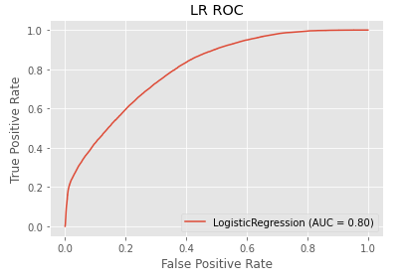
Figure 18 ROC Curve of Logistic Regression

Conclusion/Discussion
According to the analysis, many features/variables are identified, which are affecting car accident severity, including number of Vehicle/People involved, road conditions, weather, light conditions. Also found that speeding and bad weather condition do not cause higher portion of injury than POD. Currently using these selected features, the accuracy of prediction reached 72%.
both Decision Tree and Logistic Regression model have same predicting accuracy. Logistic Regression model is stable with both down-sampled data and up-sampled data.
As reviewed for the preliminary results, and the result with optimized parameter, I only had 1%-2% improvement. I am thinking that two actions need to be taken for further improvement.
- Deep correlation checking for existing features.
- Dimensionality Reduction
One-hot-encoding made lots of additional features. It will take long time to fit & predict with models. Also, might be cause overfitting problem. Dimensionality Reduction can be implemented

References
- Course resource of IBM Data Science Professional Certificate
- SciKitLearn Library
- Scipy Library
- Pandas Library
- Matplotlib Library
- Seaborn Library
- OReilly Python for Data Analysis 2nd Edition

Acknowledgment
I would like to express my appreciation to all classmates who provided me the possibility to complete this report, also thanks for the good course which is provided by IBM.

